WWW.VUTUBE.EDU.PK

FINALTERM EXAMINATION
Spring 2010
ECO401- Economics (Session - 1)
Ref No: 1375585
Time: 90 min
Marks: 69
Student Info
StudentID:
Center: | OPKST
ExamDate: | 07 Aug 2010

For Teacher's Use Only
Q No. | 1 | 2 | 3 | 4 | 5 | 6 | 7 | 8 | Total
Marks
Q No. | 9 | 10 | 11 | 12 | 13 | 14 | 15 | 16
Marks
Q No. | 17 | 18 | 19 | 20 | 21 | 22 | 23 | 24
Marks
Q No. | 25 | 26 | 27 | 28 | 29 | 30 | 31 | 32
Marks
Q No. | 33 | 34 | 35 | 36 | 37 | 38 | 39 | 40
Marks
Q No. | 41 | 42 | 43 | 44 | 45 | 46 | 47 | 48
Marks
Q No. | 49 | 50 | 51 | 52 | 53
Marks

Question No: 1 ( Marks: 1 ) - Please choose one
A good for which income and quantity demanded are inversely related is known as:

► Inferior good.
► Complementary good.
► Normal good.
► None of the given options.

Question No: 2 ( Marks: 1 ) - Please choose one
At the equilibrium price:

► There will be a shortage.
► There will be neither a shortage nor a surplus.
► There will be a surplus.
► There are forces that cause the price to change.

Question No: 3 ( Marks: 1 ) - Please choose one
A graph showing all the combinations of capital and labour available for a given total cost is the:
► Budget constraint.
► Expenditure set.
► Isoquant.
► Isocost.

Question No: 4 ( Marks: 1 ) - Please choose one
The supply curve for a competitive firm is:
► Its entire marginal cost curve.
► The upward-sloping portion of its marginal cost curve.
► Its marginal cost curve above the minimum point of the average variable cost curve.
► Its marginal cost curve above the minimum point of the average total cost curve.

Question No: 5 ( Marks: 1 ) - Please choose one
A perfectly competitive firm maximizes profit by finding the level of production at which:

► Price = Marginal Cost.
► Price = Average Total Cost.
► Average Total Cost = Marginal Cost.
► Price < Marginal Cost.

Question No: 6 ( Marks: 1 ) - Please choose one
Which of the following is true in long run equilibrium for a firm in a monopolistic competitive industry?

► The demand curve is tangent to marginal cost curve.
► The demand curve is tangent to average cost curve.
► The marginal cost curve is tangent to average cost curve.
► The demand curve is tangent to marginal revenue curve.

Question No: 7 ( Marks: 1 ) - Please choose one
Value of Marginal Product of Labor (VMP_{L}) is equal to:

► MPP_{L}/ P_{i.}
► MPP_{L.}
► P_{i.}
► MPP_{L} x P_{i.}

Question No: 8 ( Marks: 1 ) - Please choose one
The marginal revenue product is:

► Upward sloping due to the law of demand.
► Upward sloping due to the law of marginal utility.
► Downward sloping due to the law of diminishing returns.
► Downward sloping due to the law of supply.

Question No: 9 ( Marks: 1 ) - Please choose one
The classical economists thought that the economy would quickly overcome any short run instability because:

► Price level and quantity are flexible.
► Prices would get stuck at a low level.
► The long run aggregate supply would shift to the left.
► Prices and wages are flexible.

Question No: 10 ( Marks: 1 ) - Please choose one
An assumption of classical economics is:

► Investment and saving are seldom equal.
► Self-correction takes a long time.
► Demand creates its own supply.
► Prices and wages are flexible.

Question No: 11 ( Marks: 1 ) - Please choose one
Gross Domestic Product is:

► A stock variable.
► A flow variable.
► Both a stock and a flow variable.
► Neither a stock nor a flow variable.

Question No: 12 ( Marks: 1 ) - Please choose one
The labour force is made up of:

► The number of people employed minus the number of people unemployed.
► The number of people employed plus the number of people unemployed.
► Just the number of people employed.
► The whole population.

Question No: 13 ( Marks: 1 ) - Please choose one
A government wishing to reduce a deficit on the current account of their balance of payments through the use of fiscal policy would be most likely to:

► Raise direct taxation.
► Introduce an import quota.
► Raise interest rates.
► Reduce the rate of value added tax on all goods and services.

Question No: 14 ( Marks: 1 ) - Please choose one
If imports = exports, then we have:
► Current account balance.
► Capital account balance.
► Statistical discrepancy.
► Balanced Budget.

Question No: 15 ( Marks: 1 ) - Please choose one
The principle economic difference between a competitive and a non-competitive market is:

► The number of firms in the market.
► The extent to which any firm can influence the price of the product.
► The size of the firms in the market.
► The annual sales made by the largest firms in the market.

Question No: 16 ( Marks: 1 ) - Please choose one
Disposable Income is obtained by subtracting ---------------- from personal income.

► Indirect Taxes.
► Direct Taxes.
► Both direct and indirect taxes.
► Subsidies.

Question No: 17 ( Marks: 1 ) - Please choose one
Under monopoly, when the demand curve is downward sloping, marginal revenue is:

► Equal to price.
► Equal to average cost.
► Less than price.
► More than price.

Question No: 18 ( Marks: 1 ) - Please choose one
Which of the following statements is TRUE about the Classical and Keynesian approaches to achieve a macroeconomic equilibrium in an economy?
► Keynesian economists actively promote the use of fiscal policy while the classical economists do not.
► Keynesian economists actively promote the use of monetary policy to improve aggregate economic performance while the classical economists do not.
► Classical economists believe that monetary policy will certainly affect the level of output while the Keynesians believe that money growth affects only prices.
► Classical economists believe that fiscal policy is an effective tool for achieving economic stability while the Keynesians do not.

Question No: 19 ( Marks: 1 ) - Please choose one
Suppose an economy is at full employment equilibrium in the classical model. What will be the long run effect of an increase in government spending in this economy?
► Price level will increase.
► The aggregate demand curve will shift upward.
► Output level will remain constant.
► All of the given options.

Question No: 20 ( Marks: 1 ) - Please choose one
This year, if national product at factor cost is Rs. 500 billion, indirect taxes 150 billion and subsidies Rs. 50 billion, then national product at market prices will be:
► Rs. 700 billion.
► Rs. 650 billion.
► Rs. 600 billion.
► Rs. 300 billion.

Question No: 21 ( Marks: 1 ) - Please choose one
Which of the following is an example of an injection?
► Taxes.
► Saving.
► Imports.
► Investment.

Question No: 22 ( Marks: 1 ) - Please choose one
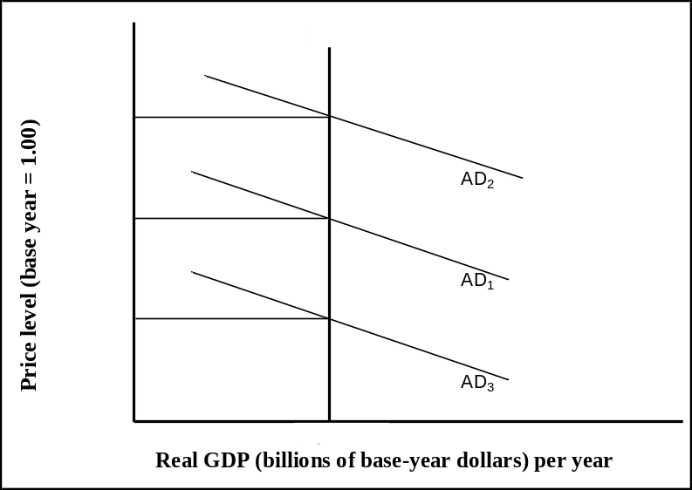
Refer to the above figure, the potential output in this economy is:
► $7,000 billion at a price level of 1.16.
► $7,000 billion at a price level of 1.12.
► $7,000 billion at a price level of 1.08.
► All of the given options.

Question No: 23 ( Marks: 1 ) - Please choose one
Refer to the above figure, if the real GDP is $7,000 billion and the implicit price deflator is 1.16, what is the value of nominal GDP?
► $6,034 billion.
► $8,120 billion.
► $9,120 billion.
► Cannot be determined from the given information.

Question No: 24 ( Marks: 1 ) - Please choose one
Which of the following is TRUE?
► Accelerator coefficient = Marginal capital / output ratio.
► Accelerator coefficient > Marginal capital / output ratio.
► Accelerator coefficient < Marginal capital / output ratio.
► None of the given options.

Question No: 25 ( Marks: 1 ) - Please choose one
Which of the following predictions can be made using the growth rates associated with the equation of exchange, given that velocity is stable and that the economy moves to its potential output (Y_{P}) in the long run?
► If the money supply grows at a faster rate than growth in Y_{P}, there will be inflation.
► If the money supply grows at the same rate as growth in Y_{P}, the price level will fall and there will be deflation.
► If the money supply grows at the same rate as growth in Y_{P}, the price level will also increase at the same rate as growth in Y_{P},.
► None of the given options.

Question No: 26 ( Marks: 1 ) - Please choose one
Which of the following will influence a country's exports?
► All of the given options.
► Consumer tastes for domestic and foreign goods.
► Prices of goods at home and abroad.
► Costs of transporting goods from country to country.

Question No: 27 ( Marks: 1 ) - Please choose one
Disposable Personal Income  $ | Consumption  $
100 | 140
200 | 220
300 | 300
400 | 380
500 | 460
Refer to the above table, when disposable personal income is $100, what is the amount of personal saving?
► −$40.
► −$20
► $0.
► $20.

Question No: 28 ( Marks: 1 ) - Please choose one
Disposable Personal Income  $ | Consumption  $
100 | 140
200 | 220
300 | 300
400 | 380
500 | 460
Refer to the above table, when disposable personal income is $400, what is the amount of personal saving?
► −$40.
► −$20.
► $0.
► $20.

Question No: 29 ( Marks: 1 ) - Please choose one
The price of one unit of foreign good in terms of domestic good is known as:
► Inflation rate.
► Real exchange rate.
► Nominal exchange rate.
► Discount rate.

Question No: 30 ( Marks: 1 ) - Please choose one
Development is impossible without:
► Incentive to profit.
► Foreign aid.
► Domestic savings.
► Inflation.

Question No: 31 ( Marks: 1 ) - Please choose one
Which of the following is not likely to be a cause of economic growth?
► Improved rate of capital formation.
► Increase in money supply.
► Increase in investment in education and training.
► Rapid technical progress.

Question No: 32 ( Marks: 1 ) - Please choose one
The money multiplier is the reverse of:
► Legal reserves.
► Excess reserves.
► Checkable deposits.
► The reserve ratio.

Question No: 33 ( Marks: 1 ) - Please choose one
A primary function of a central bank is to:
► Regulate dividend payments by corporations.
► Control the bond market.
► Set monetary policy.
► Publish statistics on banking and related financial matters.

Question No: 34 ( Marks: 1 ) - Please choose one
What will be the impact of an increase in taxes?
► It will shift the IS curve to the left and decrease both the interest rate and the level of income.
► It will shift the IS curve to the right and increase both the interest rate and the level of income.
► It will shift the IS curve to the right and increase the level of income but decrease the interest rate.
► It will shift the LM curve downward (to the right) and increase the level of income but decrease the interest rate.

Question No: 35 ( Marks: 1 ) - Please choose one
IS curve shows the equilibrium in:
► Money Market.
► Goods Market.
► Labor Market.
► Financial Market.

Question No: 36 ( Marks: 1 ) - Please choose one
Which of the following is TRUE for investment function and the IS curve slope?
► It is upward because higher interest rates induce more investment.
► It is upward because higher interest rates induce less investment.
► It is downward because higher interest rates induce more investment.
► It is downward because higher interest rates induce less investment.

Question No: 37 ( Marks: 1 ) - Please choose one
Suppose the price of rail tickets decreases, what will happen to the demand for airline travel?
► The demand curve for airline travel shifts left.
► The demand curve for airline travel shifts right.
► The supply curve of airline travel shifts left.
► The supply curve of airline travel shifts right.

Question No: 38 ( Marks: 1 ) - Please choose one
Suppose all inputs are increased by 20% but output increases by less than 20% in a production process. This means that the firm experiences:
► Decreasing returns to scale.
► Constant returns to scale.
► Increasing returns to scale.
► None of the given options.

Question No: 39 ( Marks: 1 ) - Please choose one
What will happen if current output is less than the profit-maximizing output?
► The next unit produced will decrease profit.
► The next unit produced will increase cost more than it increases revenue.
► The next unit produced will increase revenue more than it increases cost.
► The next unit produced will increase revenue without increasing cost.

Question No: 40 ( Marks: 1 ) - Please choose one
In which of the following situations, a monopoly occurs?
► When each firm produces a product that is slightly different from the other firms.
► When one firm sells a good that has no close substitutes and a barrier blocks entry for other firms.
► When there are many firms producing the same product.
► In all of the given situations.

Question No: 41 ( Marks: 1 ) - Please choose one
Concentration ratio is used to assess:
► The level of competition in an industry.
► The degree of control over prices.
► The technological gaps between the firms.
► Marginal cost and marginal benefit analysis.

Question No: 42 ( Marks: 1 ) - Please choose one
If an increase in price increases the total revenue then:
► Demand is elastic.
► Demand is inelastic.
► Supply is elastic.
► Supply is inelastic.

Question No: 43 ( Marks: 1 ) - Please choose one
Revaluation of the currency encourages:
► Imports.
► Exports.
► Poverty.
► Inflation.

Question No: 44 ( Marks: 1 ) - Please choose one
Growth rate of total output is equal to:

► Growth rate of per capita income - Growth rate of population.
► Growth rate of population / Growth rate of per capita income.
► Growth rate of population + Growth rate of per capita income.
► Growth rate of population - Growth rate of per capita income.

Question No: 45 ( Marks: 1 ) - Please choose one
Government can borrow from domestic banking system or general public by selling:
► Shares of any of its institute.
► Stocks.
► Treasury bills.
► Debentures.

Question No: 46 ( Marks: 1 ) - Please choose one
Which of the following is an equilibrium condition in goods market?
► Investment = Saving.
► Money supply = Money demand.
► Aggregate demand = C + I + G + NX.
► Aggregate demand = Aggregate supply.

Question No: 47 ( Marks: 1 ) - Please choose one
If the exchange rate is fixed, expansionary fiscal policy would not have any:
► Investment multiplier effect.
► Crowding out effects.
► Government spending effect .
► None of the given options.

Question No: 48 ( Marks: 1 ) - Please choose one
The common characteristics of a developing country is:
► High growth rate.
► High literacy rate.
► Skilled labor.
► High unemployment rate.

Question No: 49 ( Marks: 3 )
Define balance of payment (BOP). How the BOP can be determined?

Answer:
A BOP is a sheet in other words an account sheet which is an accounting record of all monetary transactions between a country and the rest of the world.

These transactions include
à Payments for the country's exports and imports of goods, services, and financial capital, as well as financial transfers.

The BOP summarizes international transactions for a specific period, usually a year, and is prepared in a single currency, typically the domestic currency for the country concerned.

Surplus items:
Sources of funds for a nation, such as exports or the receipts of loans and investments, are recorded as positive/surplus items.

Deficit items:
Uses of funds, such as for imports or to invest in foreign countries, are recorded as a negative or deficit item.

It can be determined if we see the things in both prespective.In other words it is a non-complicated way, lets assume that we have two countries Pakistan and united states and things are viewed from Pakistan point of view.

For this purpose we must now the market for foreign exchange. Foreign exchange in a Pakistani context means US $ and in a US point of view it is Pak rupees.

Question No: 50 ( Marks: 3 )
Explain the shape of money demand curve with the help of diagram.

Answer:

Money demand Md increases with income levels.

Money demand Md falls with interest rates.

In this concept we are talking about real income and real interest rate not the nominal income and nominal interest rate.

So this implies to the demand of real money.

Whether nominal and real money supply is equal or not depends much on the assumption regarding prices. If prices are assumed fixed, then the two are equal, otherwise not.

As you can see from the diagram where money demand in on the x-axis and income is on the y-axis, and there are various level showns like L1,L2,L3.

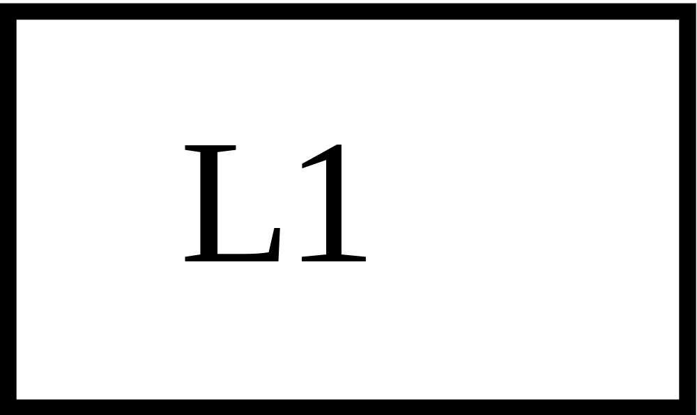
L1
L3
- Y
Y
i
o
Money Demand
L
Money demand curve
L2

Question No: 51 ( Marks: 5 )
How can a current account, which is in deficit, be restored to balance under fixed exchange rate regimes?

Answer:

There is solution for how can a current account which is in deficit be restored to balance under fixed exchange rate regimes. The answer is “Economic Deflation”

Economic Deflation says When a country’s national income rises, it spends more; part of that spending falls on imported goods; higher imports cause the current account to worsen.

The reverse is also true for this lower income must reduce import spending and therefore improve the current account spending.

However, economic contraction is not a good idea to restore current account equilibrium the other alternative solution presented by economist is to devaluate or “devaluation”.

Devaluation is the phenomena related to exchange rate where exchange rate faces depreciation but in the context of fixed exchange rates. The complement of devaluation is revaluation.

A concept of devaluation is to bring the exchange rate in line with its long-run equilibrium level, i.e. a level consistent with international competitiveness.

Competitiveness is simply defined as the real exchange rate RER, where RER = (Pf/Pd)*NER. Where

NER à Nominal Exchange rate

Pf à is the price level prevailing in the foreign country (US)
Pdà is the price level prevailing in the home country (Pakistan).

The formula implies that, for a fixed NET if inflation is higher in Pakistan (relative to
the US), Pakistani exports will become less attractive in the international market. As a result, our exports will fall, and current account will go into deficit.

To fix this problem, the NER can be devalued so as to make our goods cheaper and competitive and it is to bring competitiveness back to its original higher level. However, there are many provisos attached to the devaluation policy prescription.

Devaluation only works if the country’s exports and imports are elastic, otherwise the price effect of the devaluation will dominate the volume effect and the current account will worsen. Secondly, the country must have excess productive capacity in order to meet the higher demand for exports that is created as a result of the devaluation. Thirdly, the country should not have a very high foreign debt whose burden increases so much as a result of the devaluation that the negative effects associated therewith overwhelm any positive competitiveness effects.

Capital account (+ or -)
+ à Incoming FDI, FPI or other private capital
- àOutgoing FDI, FPI or other private capital
+ à Borrowing, aid inflows
- àPayments of debt principal, aid outflows

Question No: 52 ( Marks: 5 )
Identify which of the following are stock variables and which are flow variables?
- UnemploymentàStock
- Redundancies (job lay-offs)àFlow
- ProfitsàFlow
- A firm’s stock market valuation (share price)àStock
- The value of property after a period of inflationàStock
(Marks: 1 for each)

Question No: 53 ( Marks: 5 )
World Bank suggests some structural reform policies for the poor countries to grow. Discuss those policies briefly.
Ans:

World Bank has suggested following policies for the poor countries to grow,

      - Governance and administrative reforms: To reduce over employment in public sector, reduce wastes and to improve the quality and reliability of public services. To strengthen the administration of taxes, to eliminate the corruption. To decentralize the control of fiscal policy making. To enrich the legal and regulator framework.

      - Privatization of state-owned enterprises: Abbreviated as SOEs. These are influenced by political interference and it is one of the reasons SOEs are considered inefficient. SOEs are also suffering form lack of competition, cost awareness and fear of bankruptcy.

      - Financial liberalization: It involves ending of financial repression policies including artificially low interest rates, credit rationing, restrictions on banking competition and government involvement in investment allocation

4. Liberalization of prices, removal of subsidies

5. Deregulation involving dismantling of licensing systems and red-tape

6. Trade liberalization: including tariffication of non-tariff-barriers, harmonization of tariffs and an eventual reduction thereof

7. FDI liberalization: To create a transparent, predictable environment for foreign investors to operate in.

8. Capital account liberalization: To remove controls on capital flows

These policies are suggested by world bank and the successful implementation of these policies depend on the political and economic system of poor countries. In general these policies are expected to provide the poor nation with better understanding and help them to raise their growth.

